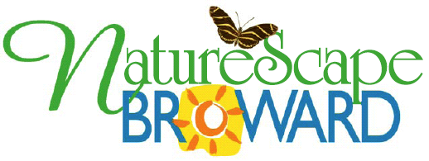

NatureScape Emerald Award Application

Category ____ Homeowner
____ Business
____ Government/Municipalities/School
____ Special Achievement
NEW ____ Legacy (Emerald Award winner five or more years ago)
NEW ____ Landscape Architect or Landscape Designer (Firm or Individual)

Name _______________________
Address _______________________
_______________________
_______________________
Phone _______________________
Email _______________________

Nominated by ____ NatureScape Volunteer or Staff
____ Self
____ Other

Yard or landscape is certified as (check all that applies):
____ Florida Friendly Yard (UF/IFAS Florida Yards and Neighborhoods Program)
____ Certified Wildlife Habitat (National Wildlife Federation)
____ Schoolyard Habitat Site (National Wildlife Federation)

Has property received any other awards? Name of award(s) _____________________________

Approximate property size: ____ 0 – ½ acre
____ ½ -1 acre
____ 1 + acre
____ Acres

Please summarize highlights of landscape. Describe what makes it a model NatureScape property.

Is the yard managed to control water intensive and prohibited invasive exotic plants?

____ Yes ____ No Comments ________________________________

Have you been cited for any environmental violations in the past year?

____ Yes ____ No If yes, please explain.

List native plant species (common names are acceptable) in your landscape. Please attach a separate sheet if necessary.

Do we have your permission to use pictures of you and your property in NatureScape literature, programs, and on the NatureScape website?

____ Yes ____ No ________________________ Signature
________________________ Date

Please attach 3 to 5 pictures of your landscape to this application. Pictures should not include homeowners.

- Current elected officials are not eligible to apply under the homeowner category.
- Applications will be reviewed by the NatureScape Emerald Award Committee.
- Qualifying landscapes will be visited in January to determine finalists.
- Final judging will take place in February.
- Homeowners are not to have contact with committee members and/or judges at the time of site visits.

Thank you for your participation!
Please submit application by December 31.
Send application to:

Rose Béchard Butman
Broward County Environmental Planning and
Community Resilience Division
115 South Andrews Avenue Room 329 H
Fort Lauderdale FL 33301
or by email mailto:rbechardbutman@broward.org

If you have any questions, please call Rose Béchard Butman 954-519-0317

